**HTML <td> charoff Attribute**

Last Updated : 04 Oct, 2024

The **HTML <td> charoff attribute** specifies the offset for aligning text around a specified character within a table cell. It is used with the char attribute and is now considered obsolete in modern HTML. This attribute can only be used in the **char** attribute and the **align**attribute is specified in the [**td**](https://www.geeksforgeeks.org/html-td-tag/) element.

***Note:*** *The <td>* ***charoff*** *attribute is not supported by HTML5.*

**Syntax**

<td charoff="number">

**Attribute Values**

* **number:**It contains the numeric value that specifies the alignment of the [td](https://www.geeksforgeeks.org/html-td-tag/) element.
  + **Positive values:** Indicate the alignment to the right of the characters.
  + **Negative values:** Indicate the alignment to the left of the characters.

**Example**: In this example we creates a table using the <td> charoff attribute to align content based on character offset. However, the charoff attribute is now obsolete.



1

<!DOCTYPE html>

2

<html>

3

​

4

<head>

5

<title>HTML td charoff attribute </title>

6

<style>

7

body {

8

text-align: center;

9

}

10

​

11

h1 {

12

color: green;

13

}

14

​

15

th {

16

color: blue;

17

}

18

​

19

table,

20

tbody,

21

td {

22

border: 1px solid black;

23

border-collapse: collapse;

24

}

25

</style>

26

</head>

27

​

28

<body>

29

<center>

30

<h1>GeeksforGeeks</h1>

31

<h2> HTML td charoff Attribute</h2>

32

<table>

33

<thead>

34

<!-- tr tag starts here -->

35

<tr align="char" charoff=".">

36

<th>Country_name</th>

37

<th>Ranking</th>

38

</tr>

39

<thead>

40

<tbody>

41

<tr>

42

<td align="char" charoff=".">

43

China</td>

44

<td>34</td>

45

</tr>

46

<tr>

47

<td>India</td>

48

<td>45</td>

49

</tr>

50

</tbody>

51

</table>

52

</center>

53

</body>

54

​

55

</html>

**Output:**

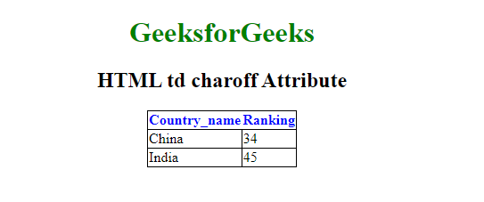Google Chrome Not supported

• Internet Explorer Not supported

• Firefox Not supported

• Apple Safari Not supported

• Opera Not supported

**HTML <td> charoff Attribute – FAQs**

**Can I still use charoff for text alignment in tables?**

*It is not recommended as it is deprecated and lacks support in modern web development.*

**What is the alternative to the charoff attribute in modern HTML?**

*Use CSS for text alignment*